Project Proposal Document - Team Bellissimo

**Project ID:** 14

**Project Title:** [Weak-Light Image Enhancement Method Based on Adaptive Local Gamma Transform and Color Compensation](https://pdfs.semanticscholar.org/6d16/d5c12f0c9b4fa23b2c8ddc9926684f2e602c.pdf?_ga=2.188067692.574436969.1635482280-1112995137.1635482280)

**Github Link:** <https://github.com/Digital-Image-Processing-IIITH/dip-project-bellissimo>

**Team Members**

1. Ainesh Sannidhi (2019101067)
2. Anandhini Rajendran (2019101055)
3. Kunwar Maheep Singh (2019101075)
4. Mayank Jain (2019101023)

**Main Goal(s)**

The main goal of this project is to implement the model defined in this paper from scratch and improve on it in any areas possible.

1. Image enhancer based on local gamma transformation and illumination model which is more adaptive to uneven illumination and enhance the visual effects of the image.
2. Achieve lesser complexity than the existing methods.
3. Graphical User Interface for easy use and access of the illumination model.

**Problem Definition**

A variety of fields such as industrial production, video surveillance, intelligent transportation, and remote sensing use computer vision. Under poor and complex light conditions during image acquisition, such as low light, uneven light, the image can become distorted affecting not only human visual perception but also the object recognition.

In weak-light environments, images suffer from low contrast and a subsequent loss of details. Weak light image enhancement has become a focus for researchers worldwide. However, traditional image enhancement models are limited in adaptivity and tend to over enhance some local areas in the case of uneven illumination.

This method is suitable for processing colour images and can adjust the parameters according to the light distribution and adaptively reduce the influence of uneven illumination on the image, thus providing a valuable reference for the study of the correction of images acquired under uneven lighting conditions.

**Approach**

1. **RGB space to YUV space:** Convert the source image to YUV space. U, V are the chrominance components and Y is the brightness component.

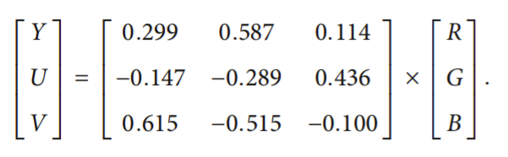

1. **Illumination component estimation:** The brightness component is eliminated from the Y space using a fast guided filtering function. The guided filtering algorithm is a guided image-based local linear transformation that obtains the low-frequency information from the image while retaining the edge information and has low computational complexity.
2. **Local gamma transformation:** Local gamma transform enhancement is performed on the image through adaptive adjustment according to the gray distribution of the brightness component.
3. **Grayscale stretching:** The contrast of the image is adjusted via grayscale linear stretching. A simple linear pointwise operation is performed to expand the histogram of the image to include the entire grayscale range.
4. **Saturation enhancement:** Color compensation strategy is applied to get back the RGB image.

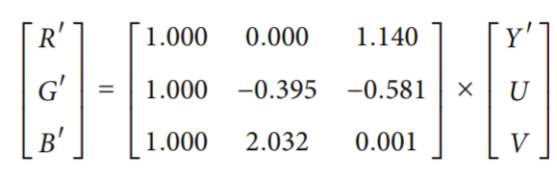

**Results**

We will implement this local gamma transformation and illumination model, compare with available open-source methods, and create a Graphical User Interface that allows users to input images, transform them according to our tool and view the resultant image. We will also show the histograms and colour bars of the original and transformed images apart from the images themselves.

**Milestones and Timeline**

**5th Nov - 9th Nov:** Literature Review and preparation of Project Proposal Document

**10th Nov - 13th Nov:** Implementing basic code layout without functionality and planning

**14th Nov - 21st Nov:** Code Implementation of Project

**22nd Nov - 25th Nov:** Implement Graphical User Interface

**26th Nov - 29th Nov:** Create Final Presentation/Report

**Dataset**

We will be using the [ExDark](https://drive.google.com/file/d/1GZqHFzTLDI-1rcOctHdf-c16VgagWocd/view) dataset which is the largest collection of low-light images taken in very low-light environments to twilight. This will be used for testing purposes.